Inflation

This diagram shows how particles in the air are moving.
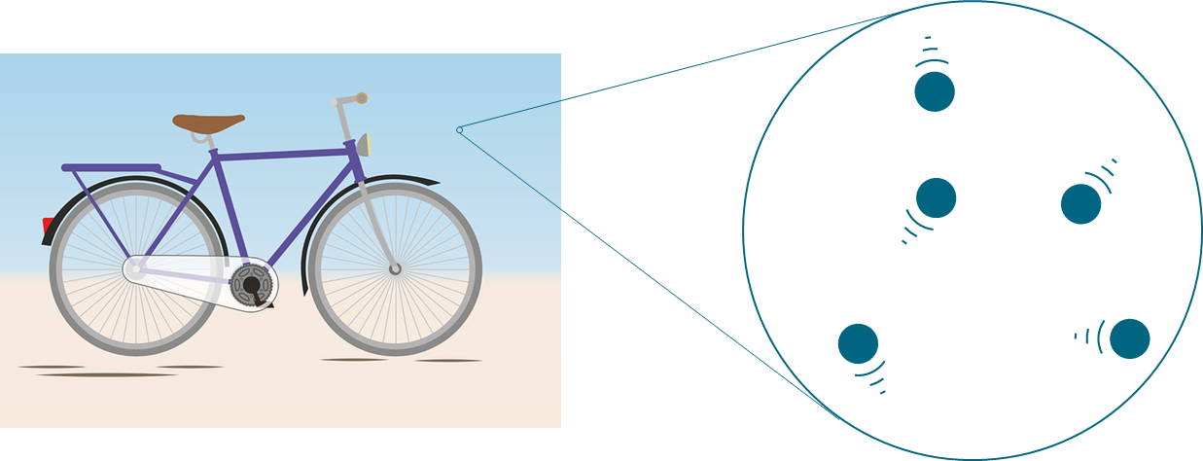

1. What do you think about the particles of air?
For each statement, tick (✓) one column to show what you think.
 |  | I am sure this is right | I think this is right | I think this is wrong | I am sure this is wrong
A | There is air between the particles.
B | The particles are moving very, very quickly.
C | The particles move freely in every direction.

A bicycle pump squeezes air into a tyre.
This makes the tyre hard.
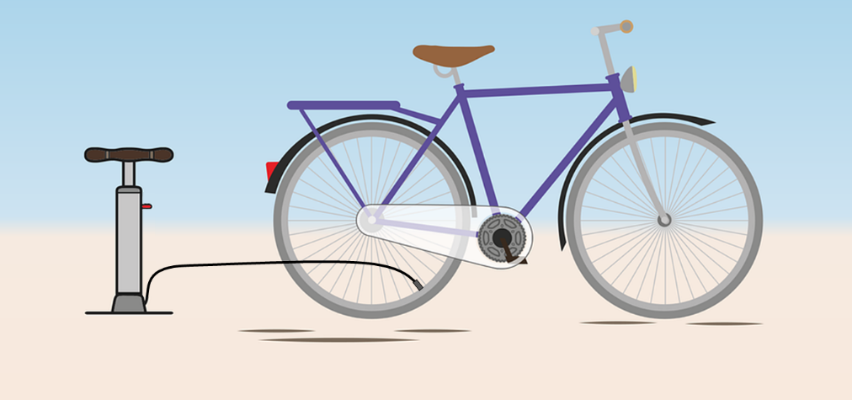

2. Which diagram best shows the particles of air inside the tyre?
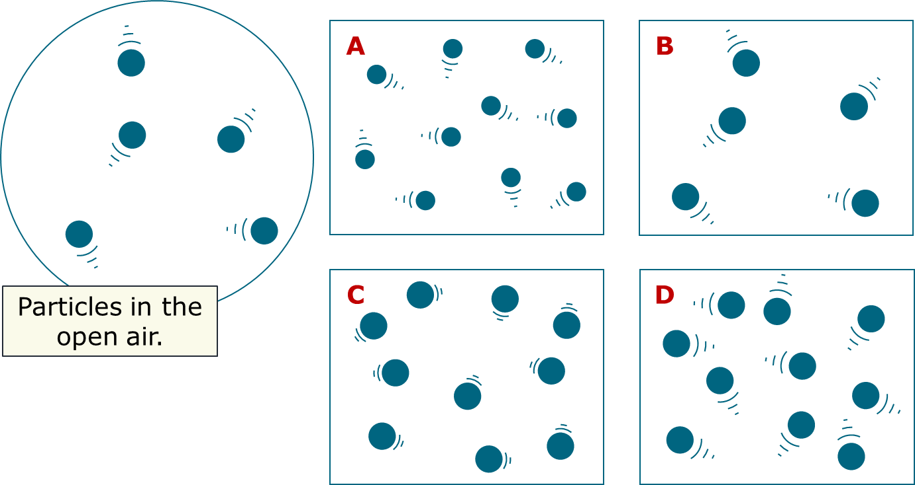

Physics > Big idea PMA: Matter > Topic PMA2: Floating and sinking > Key concept PMA2.2: Pressure in fluids
Diagnostic question
Inflation

Overview
Learning focus: | Pressure increases with depth in a fluid, so the force exerted by a fluid is larger on the lower surface of an immersed object than on the upper surface. This results in an upward force on the object.
Observable learning outcome: | Describe the movement of particles in fluids on either side of a boundary.
Question type: | Confidence grid and simple multiple choice
Key words: | Particle, gas, random

P | PRIOR UNDERSTANDING  This diagnostic question probes understanding of ideas that are usually taught earlier in the learning sequence of students aged 11-14, to aid transition from earlier stages of learning.

What does the research say?
In his paper on the progression in children’s understanding of basic particle theory, Johnson (1998) summarises findings from previous research. Children’s understanding of particles in liquids and gases revealed several misunderstandings that included:
- Intrinsic motion of particles – Students showed very little appreciation of the movement of particles.
- The ‘space’ between the particles – The idea that there is ‘nothing’ between particles, even in the gas state, caused difficulties for many students.
- The nature of the particles – Many students gave macroscopic properties to the particles, seeing them as a fragmentation of the substance as a whole.
Ways to use this question
Students should complete the questions individually. This could be a pencil and paper exercise, or you could use an electronic ‘voting system’ or mini white boards and the PowerPoint presentation.
If there is a range of answers, you may choose to respond through structured class discussion. Ask one student to explain why they gave the answer they did; ask another student to explain why they agree with them; ask another to explain why they disagree, and so on. This sort of discussion gives students the opportunity to explore their thinking and for you to really understand their learning needs.
Differentiation
You may choose to read the questions to the class, so that everyone can focus on the science. In some situations it may be more appropriate for a teaching assistant to read for one or two students.

Expected answers
1. Statement A is wrong; B and C are correct.
2. D – is the best representation of particles inside the tyre.
How to respond - what next?
1. Often students think of air as a continuous substance, and not something made up of particles. They may combine this misunderstanding with the idea of particles, and say that there is air between the particles of a gas.
Students may need to review previous understanding to remember that gas particles are moving extremely quickly (several hundred metres per second), and are moving randomly in every direction, even at relatively cool temperatures.
2. Particles in the tyre are moving at the same speed as in the air, because they are at the same temperature (so not answer C). More air particles have been put into the tyre (not B), but the particles themselves do not change size, so answer D is correct.
Some students who think of particles as fragments of the whole substance may imagine that the air particles are squashed smaller (A) because more air has been squeezed into the tyre and there is less space for each one.
If students have misunderstandings about the movement of air particles inside and outside the tyre, it may be necessary to spend time reviewing earlier ideas about particles in solids, liquids and gases. The BEST ‘key concept’ from Chemistry: CPS1.1, Particle model for the solid, liquid and gas states could be used to do this.
Acknowledgments
Developed by Peter Fairhurst (UYSEG).
Images: Peter Fairhurst (UYSEG); bicycle and pump: https://pixabay.com/illustrations/bike-accessories-helm-bottle-4168960/
References
Johnson, P. (1998). Progression in children's understanding of a 'basic' particle theory: a longitudinal study. International Journal of Science Education, 20(4), 393-412.

